MALDON HOUSING ASSOCIATION – ANNUAL REPORT

The Association’s Annual report for 2014/15 is now available to study. This report was prepared before I arrived at the Association and I would welcome any comments/observations. In particular, I would welcome your views on

1 What did you like or dislike about the Report?
2 What information do you feel was missing from this Report?
3 How can we improve the Annual Report next year?

Please reply directly to me:

david@maldonha.co.uk

David Sice
Chief Executive

Chairman’s Report

Maldon Housing Association underwent considerable change this year. It looked at its core operations and made significant changes in its management structure and it’s financing. It looked beyond its boundaries at the housing developments happening in Maldon and sought to find a way to join in and expand our housing stock.

Stacy Hember and John Williams have figured prominently in the Association’s fundraising efforts. Stacy secured £10,000 from Robert McAlpine Foundation towards our programme of bathroom adaptations. Both have been central to negotiations with the Maldon Mud Race Committee to organise Maldon’s first half marathon in September; we will be joint beneficiaries.

Our Support Manager, Rob Keeble’s role has changed. He has managed his team very well and developed structures and relationships which are reflected by the satisfaction of our residents and the massively reduced financial cost of voids.

Rob’s expanding work load has meant that his role has been restructured. He is no longer tied to specific shifts at our various houses.

Our Facilities Manager, Rebecca Reed really settled into her role this year. Her work has rationalised repair and maintenance work at MHA. She has brought her commercial and regulatory experience to bear within our operations and produced a programme of compliance and efficiency developments for some time to come. This has been achieved at a time of difficult financial discussions and Rebecca has ‘cut our cloth’ accordingly leaving a programme of ‘necessary’, ‘important’ and ‘desirable’ works in that order. Rebecca will be taking maternity leave later in 2015 and we wish her well and thank her. Rebecca would want me to pay tribute and offer thanks to Clifford Patten and Chris Tibballs (Chair of the Property Committee) for the advice and assistance they have offered her. Rebecca is on maternity leave and Tina Bolton is doing this role.

The Tenant Committee is looking to benefit MHA by establishing a relationship with Maldon District Council’s housing authority under new funding relationships established for home adaptation grants.

Our Chief Executive, Gill Davison has moved to a new office in Berridge House. This move reflects her new role whereby she has been more involved with strategy and less with daily operations. As such, Gill has established important relationships within our community, particularly with Paul Gayler the Strategic Housing Manager at Maldon District Council. Gill has also joined important local development groups in the areas of health and housing. She has led teams from MHA to look at a variety of housing associations in Essex and London. As a result of her work our reputation locally is high and we have developed a clearer view of ways in which we may take advantage of local developments in order for us to expand.

1
It has been an interesting year and the strength of the organisation, of its trustees and managers has been tested and coped admirably.

Malcolm McLeod
Chairman

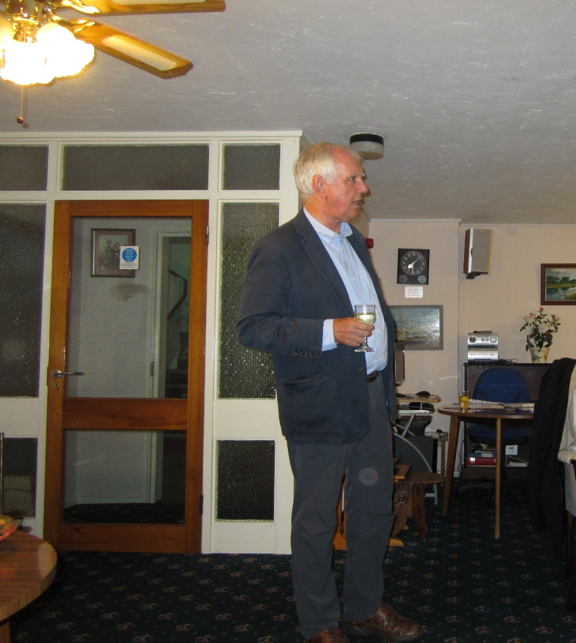

2
Fundraising
Donation

In December 2014 the Association received, from Alfred McAlpine foundation, a donation of £10,000 towards the cost of converting resident’s bathrooms into walk in shower rooms.

In January 2015 the Association and Maldon District Council through the Disability grant agreed to convert 2 bathrooms splitting the cost 50/50. This would allow the Association to convert 3 bathrooms from the donation from Alfred McAlpine Foundation. However, work is to commence in the financial year 2015/16.

Mrs Wendholt, a resident of Fairfield House, donated a garden table and chair for the residents to use at Fairfield House.

Jane Toffel and Malcolm McLeod had a stall at the Maldon Regatta in September selling photographs, cards and other items of Maldon. The proceeds which totalled £146.00 were then donated to the Association.

Sponsored events

The Association’s Fundraiser, Stacy Hember, has committed to undertake three challenges on behalf of the Association and two other charities in the 2015/16 financial year – The Brighton Marathon, Maldon Mud Race both in April and Great Stride 65 South, a 40 mile walk in the North Downs. The Association received £201.00 in sponsorship.

Other events

The residents of Fairfield House decided to enter their garden into the Maldon in Bloom competition. A judging panel were taken around the garden by the residents and the judges seemed really impressed. After several weeks of waiting for the outcome, the residents were awarded a silver award in the category Communal Garden. The residents were pleasantly surprised to win an award on their first attempt!

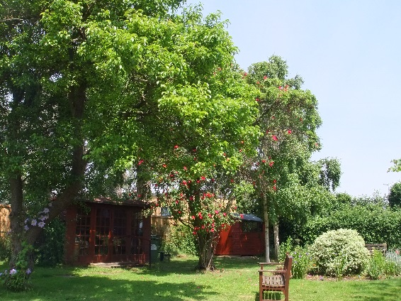
3
Service to our residents
The Association continues to rely for the most part on local contractors to undertake response repairs. Exceptions to the use of local contractors are the maintenance contracts for the central heating systems, stair lifts and passenger lift, door entry and alarm call systems.
The total number of repairs reported has decreased on the previous year and the cost of repairs has decreased by 12%. Performance has remained reasonably static with, on average, 95% of repairs being completed within target times.
Expenditure on improving the properties amounted to £55,000 in the year to 31st March 2014. The boiler at Deed House was replaced, fire safety works carried out at all buildings, and external lighting upgraded.
In addition three bathrooms were upgraded to level access shower rooms.

4
Rents/Maintenance Contributions and Lettings

Type Number of Flats

Bedsit 4

1 Bed Single Person 14

1 Bed Couple 34

2 Bed Couple 4

3 Bed Couple 1

Total 57

Assured Rent Almshouse Licence

2014/15 2013/14 2014/15 2013/14

Bedsit 109.73 104.60 109.73 104.60

1 Bed Single Person 115.74 109.75 114.91 109.73

1 Bed Couple 122.91 118.65 122.05 115.61

2 Bed Couple - - 127.61 122.19

3 Bed Couple - - 129.86 126.31

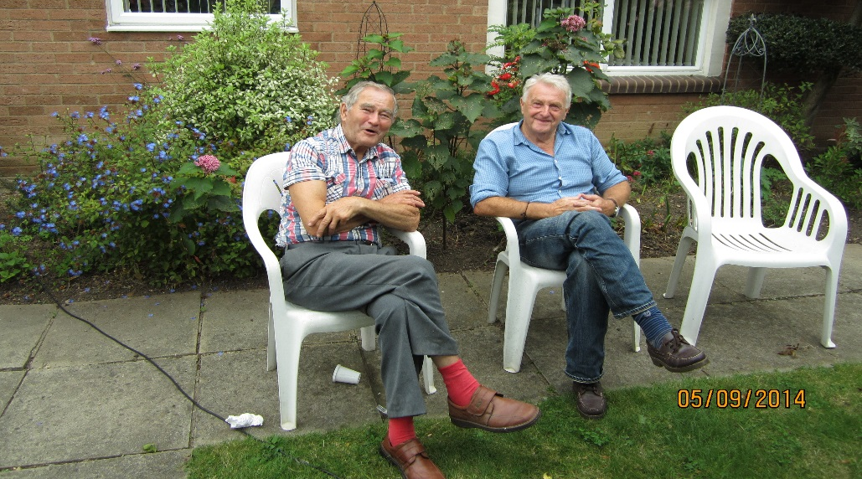

5
Some of the residents enjoying the sunshine in the garden.
Income from Rents/Maintenance Contributions

2014/15 2013/14

Total rent/maintenance contributions
receivable (including service charges
and support costs) 346,348 332,392

Voids (936) (4,534)

Rents/maintenance contributions
collectable 345,412 327,858

Grant and donation income 767 2,277

Measuring our Performance

Housing Management 2014/15 2013/14

Percentage of rents/maintenance
contributions collected 100%

Tenancy/Licence changes in the year 6 8

Percentage loss of rent/maintenance
contribution due to voids 0.27% 1.36%

Average void periods (weeks) 3.5

Number of housing applicants 31

Property Management Completed Within Number Undertaken
2015/14 2015/14

Emergency Repairs (24 hrs) 95% 62
Urgent Repairs (5 working days) 95% 126
Routine Repairs (15 working days) 96% 114

6
Expenditure Detail

How the money was spent

Set out below are details of expenditure on Repairs and Improvements, Premises, Office Costs, Staff Costs and Interest Charges.

Repairs & Improvements 2014/15 2013/14
£ £
Routine Repairs 37,794 17,166
Cyclical Repairs 5,914 9,487
Improvements & Replacements 1,725 55,028
Equipment Renewal 2,251 1,826

47,684 83,507
Premises

Lighting & Heating 30,492 33,654
Maintenance Contracts 15,470 10,962
Cleaning & Gardening 11,881 16,600
Alarm System 4,447 2,115
Insurance 5,623 5,491
Council Tax (void properties) - -
Depreciation 14,013 14,028
Sundry Expenses 2,265 3,148
Consultancy & Professional Fees - 900

84,191 86,898
Office Costs

Telephone & Stationery 4,245 6,257
Office Rates 169 165
Legal, Professional and Consultancy Fees 7,863 10,597
Other fees 2,976 2,927
Training 2,059 1,847
Sundry Expenses 4,450 6,982
Audit fee 6,000 5,970
Depreciation 1,008 915
Bad Debt Write-off - -
Repairs & Redecoration 7,299 2,761
Fundraising & Marketing Costs 3,325 3,723
Advertising & Recruitment 710 1,139

39,464 43,283

7
Expenditure Detail (continued)

2014/15 2013/14

£ £

Staff Costs 117,628 120,228

Interest Charges 8,945 11,589

Average income per unit
(excluding grant & donation
Income) 6,060 5,752

Average cost per unit 5,227 6,061

8
Expenditure information

In 2015 the Association made an operating surplus of £56,572 on a turnover of £346,179 compared to a deficit of £3,781 on a turnover of £330,135 in 2014.
Grant and donation income decreased in the year.
The Association has refurbished an area at Berridge House into an office to be used by the Chief Executive and staff at a cost of £4937.00.
In addition the Association has replaced the green house at Deed House at a cost of £1127.00.
The Association has gained a place for the Virgin London Marathon 2016 at a cost of £360.00. Sponsorships will be received in 2016/17.
The Association is in a strong financial position to continue to upgrade the housing schemes in line with the planned maintenance programme.
The number of applicants has increased and a decrease in void costs of 20%.

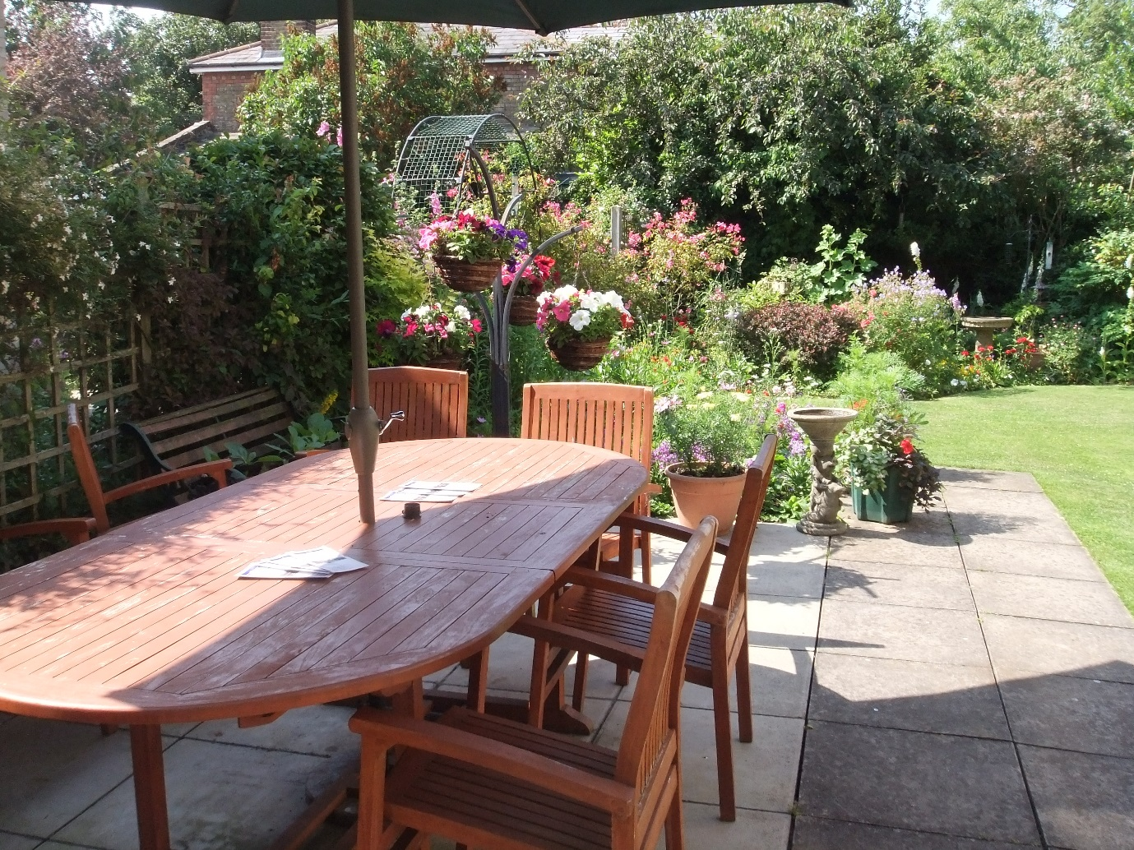
One of the new wet rooms
9
Reference and administrative details of the charity, its Trustees and advisors

Charity Registration Number: 1120475

Company Registration Number: 05972159

Almshouse Association Registration Number: M1922

Board of Directors/Trustees:

T Collin BA (Hons) MBA FCIPD FCMI FRSA (resigned 3.9.14)
M Gallagher FRICS
L Marston BA PhD
M McLeod BA (Hons) PGCE ADVDIP (Law) ADVDIP (Education)
C N Patten Dip Arch R.I.B.A.
C J Tibballs
J Toffell BA (Hons)
T Wild MA BSc CIH IOSH
J Williams FCA
J A Devenish (appointed 16.9.14)
M A Plant (appointed 7.5.15)

Chairman: M McLeod BA (Hons) PGCE ADVDIP (Law) ADVDIP (Education)

Vice Chairmen: J Toffell BA (Hons)
M Gallagher FRICS

Senior Officers: G Davison (Company Secretary,
Chief Executive, Treasurer)

R Keeble (Supported Housing Manager)

R Reed (Facilities Manager)

Registered Office: Fairfield House
33 Fambridge Road
Maldon
CM9 6AD

Bankers and National Westminster Bank plc
Similar Institutions 4-5 High Street
Chelmsford
CM1 1FZ

CAF Bank Limited
25 Kings Hill Avenue
Kings Hill
West Malling ME19 4JQ

10

Santander plc
BBAM
Bridle Road
Bootle
Merseyside GIR 0AA

Nationwide Building Society
Housing Department
Kings Park Road
Moulton Park
Northampton NN3 6NW

Orchardbrook
Crown House
Crown Street
Ipswich IP1 3HS

Aldermore Bank Plc
1st Floor, Block B
Western House
Lynch Wood
Peterborough
PE2 6FZ

Solicitors: Birkett Long LLP
Essex House
42 Crouch Street
Colchester
CO3 3HH

Statutory Auditor: Scrutton Bland
Chartered Accountants
820 The Crescent
Colchester Business Park
Colchester CO4 9YQ

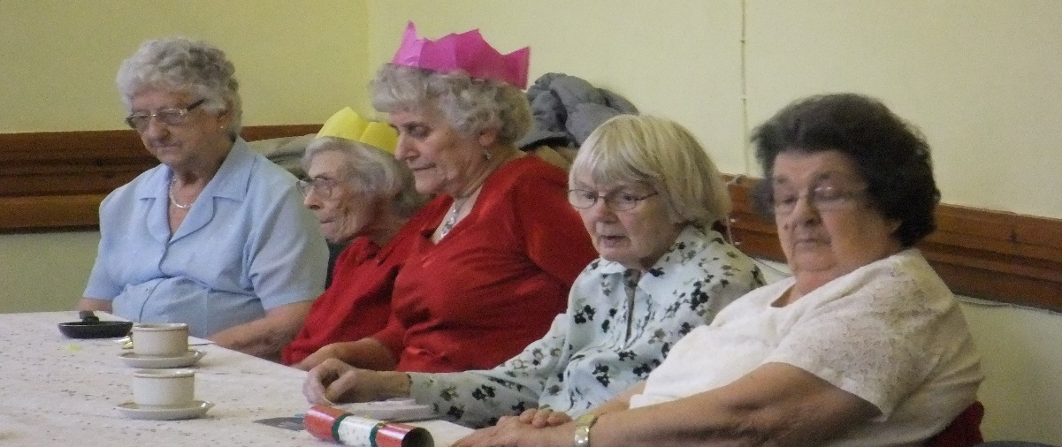

11
Trustees’ Report

Year Ended 31 March 2015

The Trustees (who are all also the directors as required by s417 of the Companies Act 2006) have pleasure in presenting their report and the audited financial statements of the Association for the year ended 31st March 2015. The financial statements are prepared in accordance with the Financial Reporting Standard for Smaller Entities (effective April 2008).

Reference and Administrative Details of the Charity, its Trustees and Advisors

Reference and Administrative Details of the charity, its Trustees and Advisors are set out on Pages 1 and 2 and form part of this report. The financial statements comply with the current statutory requirements and the Memorandum and Articles of Association.

Structure, Governance and Management

The Association is established under a Memorandum and Articles of Association. The Association joined the Almshouse Association on 1st April 2008. The Association has charitable objects and is registered with the Charity Commission.

The composition of the Board of Trustees, who are all volunteers, is reviewed annually to identify any gaps that need to be filled and address issues of balance. Trustees will be sought from all areas of the community so that a variety of skills, experience and expertise are reflected in the make-up of the Board as a whole. Trustees will be nominated by existing Trustees or be sought by open advertisement. Nominations will be considered by the Board and successful nominees will be asked to attend an interview with the Chairman, Chief Executive and one other Trustee. If, after interview, it is considered that the nominee would make a successful Trustee, details of the nominee will be circulated, in confidence, to all Trustees. If no objections are received by a specified date, the nominee will be invited to join the Board of Trustees, subject to references, formal vetting and the signing of a declaration of eligibility.

New Trustees are given a document setting out their duties and the Association’s expectations of them. An information pack is sent to new Trustees and a full induction process is arranged.

The induction process consists of :-

(i) a tour of the Association’s buildings;
(ii) a briefing on the Memorandum and Articles of Association and the statutory and legal responsibilities, including the requirements of the Charity Commission and the Homes & Communities Agency, and
(iii) a briefing on the finances
12
New Trustees will also meet existing Trustees, members of staff and residents.

Access to training courses is also available and is offered to Trustees on a regular basis.

The Board of Trustees, at the AGM, elect the Chairman and Vice Chairman and accept the retirement of those Trustees who wish to retire, or who are retiring by rotation. One third of the Trustees retire at each AGM, those longest in office retiring first. A retiring Trustee who remains qualified may normally be re-appointed for a maximum of three consecutive terms of office. However, the Trustees have the discretion to re-appoint a Trustee beyond three consecutive terms of office for a period to be determined by the Trustees, but not exceeding one further term.

Residents are encouraged to consider joining the Board of Management as a Trustee. The Chairman and Vice Chairman should hold office for a period not exceeding six years.

The Board of Trustees meets as often as is required to satisfactorily conduct the affairs of the Association and on no fewer than four times a year. Their time commitment to the Association amounts to approximately 15 to 20 hours per annum.

The Board of Trustees may delegate any of their functions to committees consisting of two or more Trustees appointed to them. All proceedings and recommendations are reported promptly to the Board of Trustees. These committees will have suitably agreed Terms of Reference which shall clearly indicate the extent of delegated powers. Committee chairmen are elected annually at the first meeting of that committee following the AGM. No Trustee will serve as a committee chairman of any one committee for more than six years consecutively.

The Board of Trustees has overall control of the charity and its property and funds. However the Trustees have authority to employ paid staff. The Chief Executive has responsibility for the day to day operations of the Association.

The Trustees and staff of the charity as at 31st March 2015 are listed in Appendix A at the back of the Trustees’ Report.

All Trustees give their time voluntarily. If applicable, any expenses reclaimed from the charity and any related party transactions requiring disclosure would be set out in note 13 to the Accounts.

13

Risk Management

The Board of Trustees is responsible for safeguarding the assets of the Association and for taking reasonable steps for the detection of fraud and other irregularities and for ensuring the Association’s efficient operation.

The Association applies a risk management cycle to identify, analyse, control and monitor the strategic and operational risks it faces. A Risk Management Policy sets out how this will be done.

The key areas of risk are as follows:-

Governance and Management
Operational
Financial
Environmental and External
Compliance with Law and Regulation

The Finance & Personnel Committee delegate to the Trustees responsible for Internal Controls Audits the responsibility for ensuring that the cycle is rigorously applied.

The Board of Trustees is satisfied that the systems in place are sufficient to mitigate these
risks.

Objectives and Activities

The objects of the charity are:

To provide and maintain Almshouses and associated services and amenities for persons who are in need of accommodation through old age, chronic sickness, disability (whether physical or mental) or necessitous circumstances.

The Association provides accommodation to people of 60 years of age or over who have connections with Maldon and are able to live independently. Accommodation is offered on the basis of housing need using the following criteria:-

(a) isolated circumstances
(b) unsuitable accommodation
(c) age and fitness

If housing need is judged to be equal between two or more applicants, preference will be given to local applicants and then by reference to time on the waiting list. The Association shares with Maldon District Council a 50/50 right to nominate residents for a vacant flat. In addition, in agreement with Maldon District Council, the Association also shares nomination rights with the Royal British Legion (TRBL) on those flats for which TRBL has funded bathroom adaptation works.

Equal access to our service by gender and disability is monitored annually.

The Association has three properties in Maldon providing high quality supported housing accommodation. Support staff are on duty between the hours of 8.30 a.m. and 4 p.m., Monday to Friday and a welfare check is made at weekends. An emergency alarm system is available outside these hours.
14
The Association is committed to promoting independence and empowering residents to have control of their own lives. The aim is to offer a ‘home for life’. By working with other professionals, such as social services and care agencies, care packages are put in place, where necessary, to ensure residents are able to live independently for as long as possible.

Residents are encouraged to participate in discussion over service improvement. Residents elect their own representatives who, together with the Supported Housing Manager, regularly meet senior officers to discuss any problems or improvements that may be required. Members of the Board of Trustees also meet with residents twice a year.

The Association aims to continue to improve the quality of the accommodation and service provided.

The Association continues to develop fundraising activities and access to grants for major works.

Funds of £3,325 were allocated during the year to enable the fundraiser to spend time accessing and applying for grant funding and raising the profile of the Association. The Trustees were delighted to receive a grant of £10,000 from the Robert McAlpine Foundation for bathroom adaptations. These funds have been allocated to the financial year ending 31 March 2016 to match expenditure on bathroom adaptations. In addition, the Association received donations totalling £767.

National Housing Federation Code of Governance

The Association has adopted the 2010 version of the National Housing Federation Code of Governance. The Association does not comply with the code in the following areas:-

Board recruitment, renewal and review:

The National Housing Federation Code of Governance states:

“To support board renewal, maximum terms of office must be two to three terms, with an overall maximum period of board service for non-executive board members of no more than nine years”.

The trustees acknowledge the importance of board renewal. Due to the size of the organisation and ongoing development of the business, the trustees wish to retain the option to allow experienced trustees to continue in office for a further term if considered necessary. The Association’s Articles of Association therefore states

“A retiring trustee who remains qualified may normally be reappointed for a maximum of three consecutive terms of office. However, the trustees have the discretion to reappoint a trustee beyond three consecutive terms of office, for a period to be determined by the Trustees, but not exceeding one further term.”

15
Constitution and Composition of the Board:

The National Housing Federation Code of Governance states:-

“……Boards should have at least five members and no more than twelve, including co-optees”.

The Association’s Articles of Association states:-

“The trustees when complete consist of at least 7 and not more than 15 individuals”.

How our Activities Deliver Public Benefit

Our main activities and who we try to help are described above. All our charitable activities focus on the provision and maintenance of Almshouses for persons who are in need of accommodation through old age, chronic sickness, disability or necessitous circumstances and are undertaken to further our charitable purposes for the public benefit. In doing so the Trustees have had regard to the Charity Commission’s Public Benefit Guidance and complied with their duties in this area as set out in Section 17 of the Charities Act 2011.

Achievement and Performance

We review our aims, objectives and activities each year. The review looks at the success of each key activity and the benefits they have brought to those groups of people we are set up to help. The review also helps us to ensure our aims, objectives and activities remain focused on our stated activities. The Association’s principal aims and objectives for 2014/15 were to:-

(i) provide and maintain almshouses for persons who are in need of accommodation
(ii) aim to offer a ‘home for life’
(iii) seek grant funding for capital works, in particular bathroom adaptations
(iv) increase the profile of the Association and raise awareness of the services provided
(v) develop the Association and its stock of residences in the light of changes in demand and housing expansion in Maldon

The Association achieved these objectives by:-

(i) gaining grant funding from the Robert McAlpine Foundation
(ii) re-letting 6 vacant flats in the year;
(iii) providing a home for life – two thirds of the vacancies were as a result of the death of the residents
(iv) holding an open day at Fairfield House
(v) engaging with local community and voluntary organisations and the local authority

16
We have referred to the guidance contained in the Charity Commission’s general guidance on public benefit when reviewing our aims and objectives and in planning our future activities. In particular, the Trustees consider how planned activities will contribute to the aims and objectives they have set.

Plans for Future Periods

We aim to develop the Association and its stock of residences to meet the anticipated increase in demand for older peoples’ housing within the Maldon District. We are actively increasing the level of publicity and marketing of the properties and services we provide. The refurbishment programme of converting bathrooms into level access shower rooms will continue in 2015/16. In addition, we continue to review the condition of our current housing stock and identify areas where design changes can be made to improve the quality of accommodation provided.

Investment Policy

The Association seeks to produce the best financial return within an acceptable level of risk.

The investment objective for the reserves is to preserve the capital value with a minimum level of risk.

Assets should be readily available to meet unanticipated cash flow requirements.

Deposits are spread between institutions, subject to the maximum compensation limit paid by the Financial Services Compensation Scheme.

The Association will draw down cash in line with the planned and operational expenditure schedules and maturity of cash deposits match this timetable.

The investment policy is reviewed annually by the Board of Management.

Financial Review

The surplus for the year to 31st March 2015 is £31,836. This is stated after £16,006 of transfers to designated reserves.

The income for the year totalling £347,858 comprises rents/maintenance contributions, service and support charges and donations. The percentage increase in income (excluding grant and donation income) compared to the previous year is 5.6%. This is mainly attributable to a decrease in voids. Donation income decreased by 66.3% compared to the previous year.

The increase in trading income is consistent with the Homes & Communities Agency requirements for rent/maintenance contribution increases and the Association’s calculation of service charge costs.

17
The expenditure in the year mainly comprises of direct costs associated with providing the support and alarm service, maintenance costs associated with the upkeep of the Association’s properties, and administration costs. The percentage decrease in these costs of 13.4% is mainly as a result of a decrease in the planned, cyclical and adaptation works.

The Board of Trustees has agreed the following designation of reserves, which in total stand at £588,657.

Designated Reserves: £

Operational expenditure 150,000
Future major works to housing properties 396,529
Miss B J Abberley bequest 34,312
Mrs E Mott bequest 3,066
Miss B Weaver bequest 2,170
Mrs E Lummis bequest 233
Miss J Barwell bequest 2,287
Mrs J Jelbart bequest 60

The reserve for operational expenditure is intended to ensure the Association could continue to provide services to the residents for up to six months should income not be received.

The reserve for future major works to housing properties reflects the Association’s commitment to maintaining the premises to the Decent Homes Standard. The Association has a ten year plan for maintenance and modernisation and the amount designated in the fund is intended to meet this plan.

The Miss B J Abberley bequest fund and the Mrs E Mott bequest fund are both intended for expenditure in respect of residents’ welfare and amounts are transferred to the income and expenditure reserves when expenditure is incurred.

The Miss B Weaver bequest fund is intended for expenditure in respect of residents’ welfare in Fairfield House and the amounts are transferred to the income and expenditure reserves when expenditure is incurred.

The Mrs E Lummis bequest fund is intended for expenditure in respect of residents’ welfare in Berridge House and amounts are transferred to the income and expenditure reserves when expenditure is incurred.

The Mrs J Jelbart bequest fund is intended for expenditure in respect of personal items required by a resident on emergency admission to hospital.

Indemnification Insurance

The Association paid £1,334 to the National Housing Federation in respect of an Indemnity Policy protecting all Trustees, committee or staff members from claims made against them in their capacity as representatives of the organisation.

18
Trustees’ Responsibilities

The Trustees, who are also directors of the Association for the purposes of Company Law, are responsible for preparing the financial statements in accordance with applicable law and United Kingdom Generally Accepted Accounting Standards.

Company law requires the trustees to prepare financial statements for each financial year which give a true and fair view of the state of the affairs of the Association and of the in-coming resources and application of resources, including the income and expenditure, of the Association for that period. In preparing these financial statements, the trustees are required to:

a) select suitable accounting policies, and apply them consistently;
b) observe the methods and principles in the Charities SORP;
c) make judgements and estimates that are reasonable and prudent
d) state whether applicable UK accounting standards have been followed, subject to any material departures disclosed and explained in the financial statements;
e) prepare the financial statements on the going concern basis unless it is inappropriate to presume that the Association will continue in operation.

The trustees are responsible for keeping proper accounting records that disclose with reasonable accuracy at any time the financial position of the Association and enable them to ensure that the financial statements comply with the Companies Act 2006, Schedule 1 to the Housing Act 1996, Accounting Requirements for Registered Social Landlords General Determination 2006, Section 24 of the Housing Association Act 1985, the Charities Act 1993, the Charity (Accounts and Reports) Regulations 2008 and the provisions of the trust deed. They are also responsible for safeguarding the assets of the Association and hence for taking reasonable steps for the prevention and detection of fraud and other irregularities.

The trustees are also responsible for the maintenance and integrity of the Association and financial information included on the Association’s website, if applicable. Legislation in the United Kingdom governing the preparation and dissemination of financial statements may differ from legislation in other jurisdictions.

The trustees confirm that, so far as they are aware, there is no relevant audit information of which the Association’s auditor is unaware. They have taken all steps that they ought to have taken as trustees in order to make themselves aware of any relevant audit information and to establish that the auditor is aware of that information.

Auditors

Scrutton Bland were appointed as auditors during the period under review and have signified their willingness to continue in office. A resolution proposing their re-appointment will be put to the Annual General Meeting.

19
Small company provisions

This report has been prepared in accordance with the special provisions for small companies under Part 15 of the Companies Act 2006.

Registered office: Signed by order of the trustees

Fairfield House
33 Fambridge Road
Maldon
Essex Mrs G Davison
CM9 6AD Secretary

Approved by the trustees on 15 July 2015.

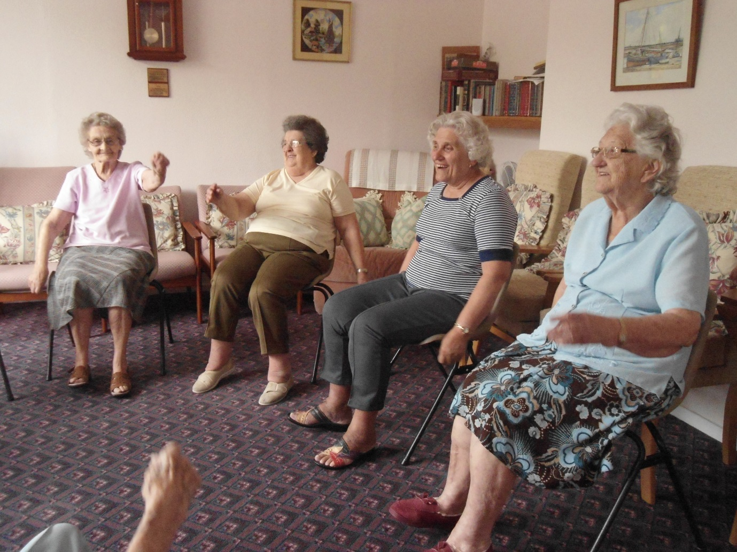

20
Trustees and staff as at 31st March 2015

Trustees:

Please see page 10

Administrative staff:

Mrs G Davison Company Secretary/Chief Executive/Treasurer
Mrs R Reed Facilities Manager
Mrs S Hember Assistant Treasurer/Fundraiser
Mrs M Stephens Office Secretary

Stacy Hember
Muriel Stephens
Rebecca Reed

Gill Davison

Support Staff:

Mr R Keeble Supported Housing Manager
Mrs L Merry Support Worker
Mrs L Padrazolla Support Worker
Mrs J Baker Relief Support Worker

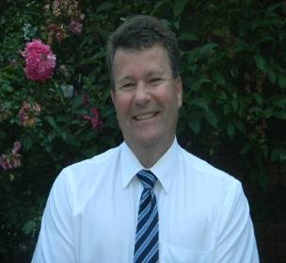

Rob Keeble

21
Trustees and staff as at 31st March 2015 (continued)

Cleaners:-

Mrs S Adam
Miss K Aldridge

Gardeners:-

Ms B Wilce
Mr J Raven
Mr T Feeney (relief)

Staff Changes:-

Mrs Rebecca Reed took up her post as Facilities Manager on 19 May 2014. Rebecca previously worked for a large company in London and her skills and expertise have been of real benefit to the Association.

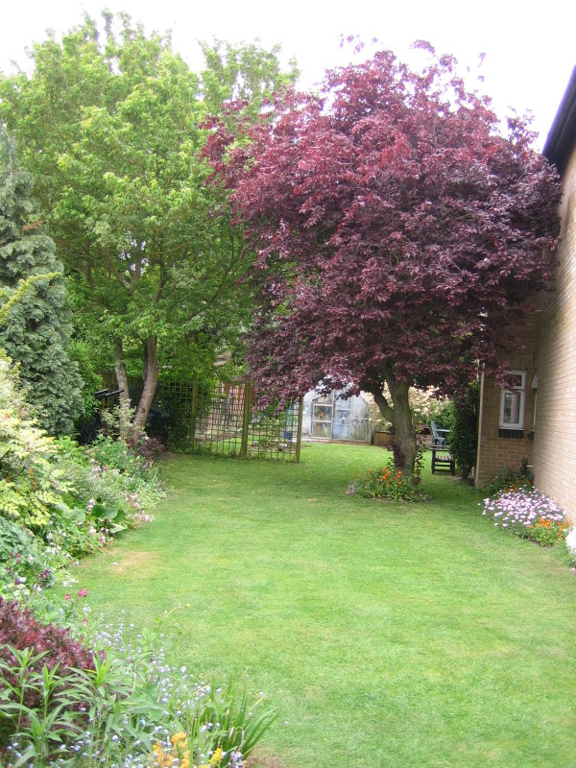

22
Statement by the Board in Respect of Internal Financial Control

The Board of Management is responsible for maintaining a system of internal financial control. It is also responsible for safeguarding the assets of the Association, for taking reasonable steps for the detection of fraud and other irregularities and for ensuring the Association’s efficient operation. It is acknowledged that the system in place can only provide reasonable and not absolute assurance against material misstatement or loss. This system has evolved over the years and is reviewed by the Board on an ongoing basis.

The Association applies a risk management cycle to identify, analyse, control and monitor the strategic and operational risks it faces, including fraud. A Risk Management Policy sets out how this will be done. The key areas of risk are as follows:-

Governance and Management
Operational
Financial
Environmental and External; and
Compliance with Law and Regulation

The Finance and Personnel Committee delegates to the Property Committee and the Trustees responsible for Internal Controls Audits the responsibility for ensuring that the cycle is rigorously applied.

In particular, these audits which incorporate a report to the Board are carried out at least once a quarter normally by two members of the Board with the aim of ensuring the adequacy and effectiveness of the implementation of:

(i) The formal policies and procedures put in place by the Board for the setting of clear lines of responsibility and the effective financial control over the various areas of the Association’s activities.

(ii) The procedures for the identification, preparation and adoption of a detailed internal audit programme covering the Association’s activities.

(iii) The provision of accurate management accounts, preparation of budgets including projected balance sheets, cash flow forecasts and regular comparison of management accounts against budgets and reports on variances and the need to consider budget changes, and

(iv) The periodic review by the Board of the overall effectiveness of the system.

The Board is pleased to report that no significant failings or weaknesses have come to light during the year under review, and to date none which have or are considered likely to result in any material loss, contingency or uncertainty. Any suggestions made for improvement during the year, which have only been minor anyway, have been absorbed quickly as part of the overall procedures.

23
Independent Auditors Report to the Board Members of Maldon Housing Association Limited
(Company Limited by Guarantee)

We have audited the financial statements of Maldon Housing Association Limited for the year ended 31 March 2015 on pages 26 to 38. These financial statements have been prepared under the accounting policies set out therein.

This report is made solely to the Association’s members, as a body in accordance with Chapter 3 of Part 16 of the Companies Act 2006. Our audit work has been undertaken so that we might state to the Association’s members those matters we are required to state to them in the auditor’s report and for no other purpose. To the fullest extent permitted by law, we do not accept or assume responsibility to anyone other than the Association and the Association’s members as a body, for our audit work, for this report or for the opinions we have formed.

Respective responsibilities of the trustees and auditor

The Trustees’ (who are also the directors of Maldon Housing Association limited for the purpose of company law) responsibilities for preparing the Trustees’ Report and the financial statements in accordance with applicable law and United Kingdom Accounting Standards (United Kingdom Generally Accepted Accounting Practice) are set out in the Statement of Trustees’ Responsibilities.

Our responsibility is to audit and express an opinion on the financial statements in accordance with relevant legal and regulatory requirements and International Standards on Auditing (UK and Ireland).These standards require us to comply with the Auditing Practices Board’s (APB’s) Ethical Standards for Auditors.

We report to you our opinion as to whether the financial statements give a true and fair view, have been properly prepared in accordance with United Kingdom Generally Accepted Accounting Practice, and have been prepared in accordance with the Companies Act 2006, the Accounting Requirements for Registered Social Housing Providers Accounting Direction 2012 and the Housing and Regeneration Act 2008. We also report to you if, in our opinion, the Trustees’ Report and Chairman’s Report is consistent with the financial statements.

Scope of the audit of the financial statements

An audit involves obtaining evidence about the amounts and disclosures in the financial statements sufficient to give reasonable assurance that the financial statements are free from material misstatement, whether caused by fraud or error. This includes an assessment of whether the accounting policies are appropriate to the Association’s circumstances and have been consistently applied and adequately disclosed; the reasonableness of significant accounting estimates made by the Trustees; and the overall presentation of the financial statements. In addition, we read all the financial and non-financial information in the Trustees’ Report and Chairman’s Report to identify material inconsistencies with the audited financial statements and to identify any information that is apparently materially incorrect based on, or materially inconsistent with, the knowledge acquired by us in the course of performing the audit. If we become aware of any apparent material misstatements or inconsistencies we consider the implications for our report.
24
Opinion

In our opinion:

- the financial statements give a true and fair view of the state of the Association’s affairs as at 31 March 2015 and of its income and expenditure for the year then ended;

- the financial statements have been properly prepared in accordance with the Companies Act 2006, the Accounting Requirements for Registered Social Housing Providers Accounting Direction 2012 and the Housing and Regeneration Act 2008; and

Opinion on other matters prescribed by the Companies Act 2006

In our opinion the information given in the Trustee’s Report for the financial year for which the financial statements are prepared is consistent with the financial statements.

Matters on which we are required to report by exception

We have nothing to report in respect of the following matters where the Companies Act 2006 requires us to report to you if, in our opinion:

- adequate accounting records have not been kept, or returns adequate for our audit have not been received from branches not visited by us; or

- the financial statements are not in agreement with the accounting records and returns; or

- certain disclosures of director’s remuneration specified by law are not made; or

- we have not received all the information and explanations we require for our audit.

TIM O’CONNOR (Senior Statutory Auditor)

SCRUTTON BLAND
Chartered Accountants and Statutory Auditor

820 The Crescent
Colchester Business Park
Colchester
Essex
CO4 9YQ

17 July 2015

25
Income and Expenditure Account
Year ended 31 March 2015

 | Notes | 2015 | 2014
 |  | £ | £
Turnover | 3 | 347,858 | 331,194
Direct property management costs |  | (192,556) | (233,975)
Gross surplus |  | 155,302 | 97,219
Administrative expenses |  | (98,730) | (101,000)
Operating surplus/(deficit) | 3 | 56,572 | (3,781)
Other interest receivable and similar  income | 4 | 215 | 750
Interest payable and similar charges | 5 | (8,945) | (11,589)
Surplus/(deficit) on ordinary activities for the financial year before transfers |  | 47,842 | (14,620)
Net transfer (to)/from designated reserves | 11 | (16,006) | 16,094
Surplus for the financial year after transfers | 12 | 31,836 | 1,474
All the activities of the Association are classed as continuing.

Statement of total recognised gains and losses

There are no recognised gains or losses in this or the prior period other than the surplus or deficit for those periods.

Name: J Devenish
Trustee

Name: J Toffel
Trustee

Name: G Davison
Secretary

Date: 15 July 2015

26
Balance Sheet
As at 31 March 2015

 |  | Notes |  | 2014 |  | 2013
 |  |  |  | £ |  | £
Fixed assets
Housing properties |  |  |  | 1,682,363 |  | 1,694,351
Less: Social Housing Grants (SHG) |  |  |  | (1,062,733) |  | (1,062,733)
 |  | 6(a) |  | 619,630 |  | 631,618
Other fixed assets |  | 6(b) |  | 15,852 |  | 17,751
 |  |  |  | 635,482 |  | 649,369
Current assets
Debtors |  | 7 |  | 16,750 |  | 8,770
Cash at bank and in hand |  |  |  | 175,968 |  | 142,735
 |  |  |  | 192,718 |  | 167,505
Creditors: amounts falling due
Within one year |  | 8 |  | (49,131) |  | (55,027)
Net current assets |  |  |  | 143,587 |  | 87,708
Total assets less current liabilities |  |  |  | £779,069 |  | £737,077
Creditors: amounts falling due
after more than one year |  | 9 |  | 96,602 |  | 102,522
Capital and reserves
Designated reserves |  | 11 |  | 588,657 |  | 572,581
Income and expenditure account |  | 12 |  | 93,810 |  | 61,974
Members' funds |  |  |  | 682,467 |  | 634,555
 |  |  |  | £779,069 |  | £737,077

27
These financial statements have been prepared in accordance with the special provisions for small companies under Part 15 of the Companies Act 2006 and with the financial Reporting Standard for Smaller Entities (effective April 2008).

The financial statements were approved by the Board members on 15 July 2015 and signed on their behalf by:

Name: J Devenish
Trustee

Name: J Toffel
Trustee

Name: G Davison
Secretary

Company Registration Number: 05972159

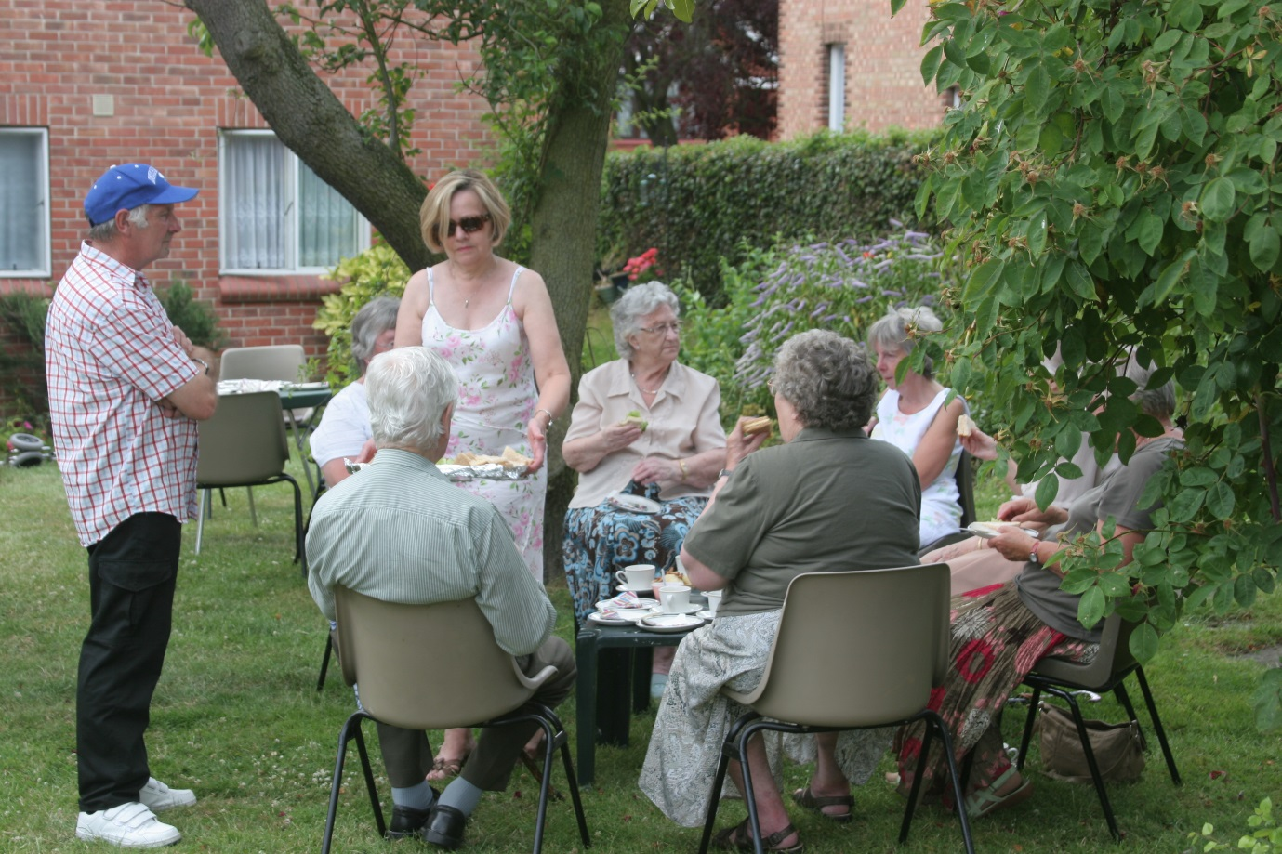

28
Notes to the Financial Statements Year ended 31 March 2015

1. Status of Association

The Association is registered under the Companies Act 2006, registered number 05972159 as a company limited by guarantee and was incorporated on 19 October 2006. It is also registered under Section 13 of the Housing Act 1974 for the purpose of receiving grants and other forms of assistance. The Association registered with the Charity Commission on 7 August 2007.

2. Accounting Policies

(a) Introduction and basis of accounting

The principal accounting policies of the Association are set out in the following paragraphs. These financial statements are prepared under the historical cost convention, and in accordance with applicable financial reporting standards and are based on the National Federation of Housing Associations’ ‘Statement of Recommended Practice’ (Accounting by Registered Social Housing Providers), and the statement of recommended practice “Accounting and reporting by charities” published in 2008, comply with the Accounting Requirements for Registered Social Housing Providers Accounting Direction 2012, and are prepared in accordance with the Financial Reporting Standard for Smaller Entities (effective April 2008).

(b) Turnover

Turnover represents rental, maintenance contributions and service charge income receivable, and where relevant income from the sale of properties, fees and revenue grants from the Homes and Communities Agency and other public authorities, donations and grant income.

(c) Mortgages

Mortgage loans are advanced by banks and building societies under the terms of individual mortgage deeds in respect of each property. Interest charges on such mortgages are recognised as an expense when incurred.

(d) Social Housing Grants

Social Housing Grants (SHG) are made by the Homes and Communities Agency in respect of capital and improvement projects. Capital grants are shown in the financial statements as a deduction from the cost of the freehold development. Improvement grants are now credited to the Income and Expenditure account in accordance with the “Statement of Recommended Practice” (Accounting by Registered Social Housing Providers).
Although SHG is treated as a grant for accounting purposes, it is repayable under certain circumstances, primarily following the sale of the property concerned.
Whilst the treatment of grants is in contravention to the Companies Act, it is felt that a true and fair override should be invoked to ensure the policy adopted is in line with the requirements of the Accounts Direction.
29
(e) Fixed assets – Housing land and buildings

Freehold housing properties are stated at cost together with incidental costs of acquisition, administration costs and interest up to the date of completion.

(f) Depreciation

(i) Housing land and buildings

Freehold land is not depreciated. Depreciation is charged so as to write down the cost (net of social housing grant) of freehold housing properties other than freehold land to their estimated residual value on a straight line basis over their expected useful economic lives at an annual rate of 2%. No release is made in respect of the social housing grant, as permitted by the Statement of Recommended Practice.

(ii) Existing properties

Amounts are capitalised where required by the Statement of Recommended Practice. In doing so their useful economic lives are considered for the purposes of depreciation. Amounts capitalised are included within the fixed asset note whilst items of a revenue nature are charged to the Statement of Financial Activities. Whilst amounts capitalised comprise both replacement components and improvements, no distinction is made due to the similar nature of the relevant assets: the implications of component accounting are not deemed to be material to the Association’s financial statements.

(iii) Other fixed assets

Office furniture, fittings and equipment are depreciated over their expected economic useful lives at the following annual rates:

Mobility scooters -25% reducing balance
Furniture, fittings and equipment - 10% - 20% straight line
or reducing balance
Computer equipment - 25% straight line

Equipment with a short life such as washing machines, televisions, fridges and cookers are accounted for on a replacement basis.

(g) Future major repairs reserve

Provision is made by transfer to a designated reserve for future major repairs. No accrual or provision is made for cyclical maintenance, it being the Association’s policy to maintain its properties in accordance with the planned programme of works, as this is accounted for when incurred.

30
(h) Apportionment of management expenses

Direct employee, administration and operating costs have been apportioned to the property revenue account and the relevant sections of the general income and expenditure account on the basis of the costs of the staff directly engaged on the operations dealt with in these financial statements.

(i) Taxation

Maldon Housing Association Limited is a charity within the meaning of the Charities Acts 2011 and as such is a charity within the meaning of Part 11, Corporation Tax Act 2010. Accordingly Maldon Housing Association Limited is potentially exempt from taxation in respect of income or gains received within categories covered by Part 11, Corporation Tax Act 2010 or Section 256 of the Taxation of Chargeable Gains Act 1992 to the extent that such income or gains are applied exclusively to its charitable purposes.

(j) Financial instruments

Financial instruments are classified and accounted for, according to the substance of the contractual arrangement, as either financial assets, financial liabilities or equity instruments.

(k) Supporting People income and expenditure

Supporting People is a programme providing contractual arrangements for the provision of housing related support to certain individuals.

Maldon Housing Association has been granted access to Supporting People monies and ensures it accounts for such income and expenditure in the prescribed manner.

(l) Designated reserves

The trustees regularly review the need for reserves in respect of future operational expenditure and future major works to housing properties.

As part of this review monies may be transferred to or from Revenue Reserve funds in order to derive an appropriate level of designated funds.

Further balances representing bequest funds are also designated and information regarding all designated reserves can be found within Note 11 to the financial statements.

(m) Operating lease agreements

Rentals applicable to operating leases where substantially all of the benefits and risks of ownership remain with the lessor are charged against profits on a straight line basis over the period of the lease.

31
3. Turnover
 | Notes | 2015 | 2014
 |  | £ | £
Income from lettings
Rents/maintenance contributions |  | 228,882 | 220,112
Service charges |  | 102,815 | 96,333
Charges for support services |  | 16,318 | 16,970
Scooter rental |  | 12 | 36
Less: Rent losses from voids |  | (936) | (4,534)
Total income from lettings |  | 347,091 | 328,917
Add:
Grant income and donations |  | 767 | 2,277
 |  | 347,858 | 331,194
Expenditure on letting activities
Service costs |  | 132,884 | 137,581
Management costs |  | 72,073 | 73,730
Routine maintenance costs |  | 74,341 | 111,676
Property depreciation |  | 11,988 | 11,988
Total expenditure on lettings |  | £291,286 | £334,975
Operating surplus/(deficit) |  | £56,572 | £(3,781)

4. Other Interest Receivable and Similar Income

2015 2014
£ £

Interest on deposits 215 650
Other income - 100

£215 £750

5. Interest payable and similar charges

2015 2014
£ £

Orchardbrook 6,006 6,029
National Westminster Bank 1,371 3,683
Nationwide Building Society 1,568 1,877

£8,945 £11,589

32
6. Fixed Assets

- Housing properties – freehold
Total
£

Cost
At 1 April 2014 and 31 March 2015
1,862,193
Depreciation
At 1 April 2014 167,842
Charge for the year 11,988

At 31 March 2015 179,830

SHG
At 1 April 2014 and 31 March 2015 1,062,733

Book value

At 31 March 2015 £619,630

At 31 March 2014 £631,618

Although fixed assets are not revalued, the Trustees are satisfied that the aggregate value of assets is in excess of the value included in the financial statements.

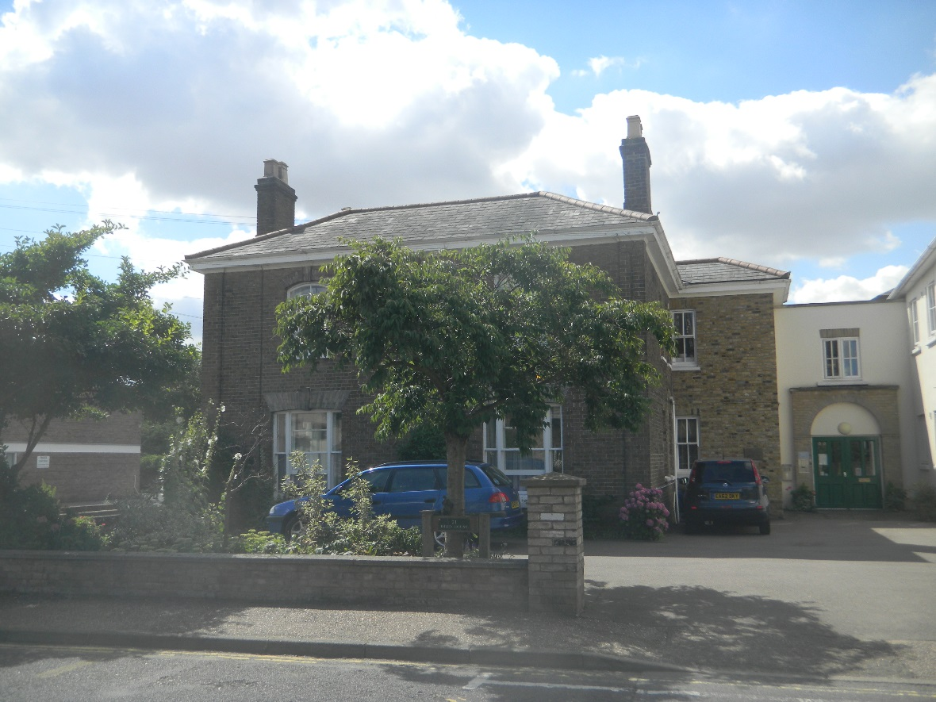

33
(b) Other fixed assets

 | Mobility | Furniture | Computer | Total
 | scooters | fittings and | equipment
 |  | equipment
 | £ | £ | £ | £
Cost
At 1 April 2014 | 1,099 | 109,739 | 4,486 | 115,324
Additions | - | 540 | 594 | 1,134
Disposals | - | - | - | -
Fully depreciated assets | - | - | (2,298) | (2,298)
At 31 March 2015 | 1,099 | 110,279 | 2,782 | 114,160
Depreciation
At 1 April 2014 | 138 | 95,404 | 2,031 | 97,573
Charge for the year | 240 | 1,673 | 1,120 | 3,033
On disposals | - | - | - | -
Fully depreciated assets | - | - | (2,298) | (2,298)
At 31 March 2015 | 378 | 97,077 | 853 | 98,308
Net book values
At 31 March 2015 | £721 | £13,202 | £1,929 | £15,852
At 31 March 2014 | £961 | £14,335 | £2,455 | £17,751

7. Debtors 2015 2014

Other debtors and prepayments £16,750 £8,770

No loans have been made or are outstanding to Board members, officials or employees.

8. Creditors: Amounts Falling Due Within One Year

2015 2014
£ £

Loans (secured – see note 9) 3,585 24,554
Other creditors 45,546 30,473

£49,131 £55,027

34
Included within other creditors and accruals is £10,000 of donation income which has been deferred. This income will be released when the related costs are incurred.

9. Creditors: Amounts Falling due After More Than One Year

Loans on mortgage secured by a charge on the Association’s housing land and buildings:

2015 2014
£ £

Loans £96,602 £102,522

Total Loans

Orchardbrook 55,057 55,287
Nationwide Building Society 43,651 46,093
National Westminster Bank 1,479 25,696

£100,187 £127,076

Debt due within one year 3,585 24,554
Debt due after more than one year:
- Repayable in one to two years 2,106 6,441
- Repayable in two to five years 6,319 7,947
- Repayable after five years (all repayable
by instalments 88,177 88,134

£100,187 £127,076

The loan advanced by Orchardbrook to finance the development of housing land and buildings will be repayable by equal annual instalments over 60 years, the last instalment of which falls to be repaid on 31 August 2045. Interest is charged at a rate of 10.875% per annum.

The Nationwide Building Society loan was initially taken out in September 1993 in order to redeem the loans with the Housing Corporation (effectively now the Homes and Communities Agency) and the local authority and to finance the cost of new windows for Berridge House. The loan is for 35 years, the last instalment of which falls to be repaid on 31 August 2028. The interest rate is variable and was 3.25% at 1 January 2015.

The National Westminster Bank loans were initially taken out in January 1995 and April 1995 to finance the cost of building works to Deed House. The loans are for 20 years, the last instalment of which falls to be repaid in March 2015 and April 2015 respectively. The interest rate is 10% on a loan originally for £170,000 and 10.75% on the loan made in April 1995 for £55,000.

35

10. Company Limited By Guarantee

The company does not have share capital and is limited by the guarantee of its nine members. If the company is dissolved while each person remains a member, or within twelve months afterwards, each member promises to pay up to £10 towards the costs of dissolution and the liabilities incurred by the company while he or she was a member.

11. Designated Reserves

 | Reserve for operational expenditure | Reserve for future major works to housing properties | Miss B J B Abberley Bequest Fund | Mrs E Mott bequest fund | Mrs B Weaver bequest fund | Mrs Lummis bequest fund | Miss J Barwell bequest fund | J Jelbart bequest fund | Total
 | £ | £ | £ | £ | £ | £ | £ | £ | £
At 1 April 2014
 | 150,000 | 380,529 | 34,243 | 3,060 | 2,165 | 232 | 2,352 | - | 572,581
Transfer From/(to) revenue reserve funds
 |  | 16,000 | 69 | 6 | 5 | 1 | (65) | (10) | 16,006
Other movements | - | - | - | - | - | - | - | 70 | 70
At 31
March
2015
 | £150,000 | £396,529 | £34,312 | £3,066 | £2,170 | £233 | £2,287 | £60 | £588,657

The reserve for operational expenditure is intended to ensure the Association could continue to provide services to the tenants for at least six months should income not be received.

The reserve for future major works to housing properties reflects the Association’s commitment to maintaining the premises to a high standard and upgrading the facilities required. The Association has a fifteen year plan for maintenance and modernisation and the amount designated in the fund is intended to meet this plan.

36
The Miss B J B Abberley bequest fund and the Mrs E Mott bequest fund are both intended for expenditure in respect of residents’ welfare and amounts are transferred to the income and expenditure reserves when expenditure is incurred.

The Miss B Weaver bequest fund is intended for expenditure in respect of residents’ welfare in Fairfield House and amounts are transferred to the income and expenditure reserves when expenditure is incurred.

The Mrs Lummis bequest fund is intended for expenditure in respect of residents’ welfare in Berridge House and amounts are transferred to the income and expenditure reserves when expenditure is incurred.

The Miss J Barwell bequest fund is intended for expenditure in respect of resident’s welfare in Fairfield House and amounts are transferred to the income and expenditure reserves when expenditure is incurred.

The Mrs J Jelbart bequest fund is intended for expenditure in respect of residents’ welfare in all three houses and amounts are transferred to the income and expenditure reserves when expenditure is incurred.

Rent Surplus Fund –forming part of the future major works reserve

2015 2014

Balance at 1 April 2014 and 31 March 2015 £8,845 £8,845

The rent surplus fund is calculated according to Homes and Communities Agency requirements.

12. Reconciliation of Movements on Revenue Reserve

2015 2014
£ £

Surplus/(deficit) on ordinary activities for the
financial year 47,842 (14,620)

Net transfer (to)/from designated reserves (16,006) 16,094

Surplus for the financial year 31,836 1,474

Opening revenue reserve funds at 1 April 2014 61,974 60,500

Closing revenue reserve funds at 31 March 2015 £93,810 £61,974

37
13. Employee and Other Costs Including Trustees

2015 2014
£ £
(a) Staff costs during the year
Wages and salaries 120,393 120,401
Social security costs 7,810 8,210
Pension contributions 2,632 3,892

£130,835 £132,503

The average number of persons employed
by the Association during the year was 12 13

The average number of persons employed
by the Association on a full time equivalent
basis, during the year was 4 4

(b) Emoluments of the Chief Executive £38,838 £41,092

(c) Auditor’s remuneration £4,900 £4,750

The Association operates a stakeholder pension scheme on behalf of certain officials and employees. During the period pension contributions of £2,198 (2014: £2,326) were made on behalf of the Chief Executive. These are included in the emoluments of 13b), above.

Transactions, including the reimbursement of expenses with board members, were not material during the year. All transactions involving organisations in which a member of the board may have an interest are conducted at arm’s length.

14. Accommodation in Management
2015 2014

Number of units of housing accommodation at
1 April 2014 and 31 March 2015 57 57

15. Control

The Association is controlled by the Board of Trustees. No one individual has overall control.

16. Operating Lease Commitments

At 31 March 2015 the company had annual commitments under non-cancellable operating leases as follows:

Expiry date: 2015 2014

Between 2 and 5 years £4,688 £4,688

38

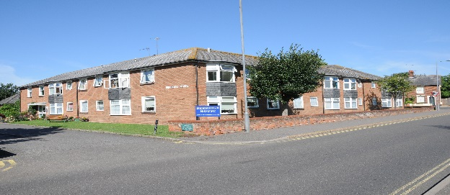
Berridge House
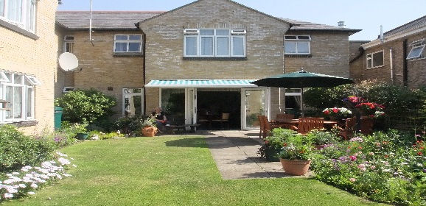
Deed House

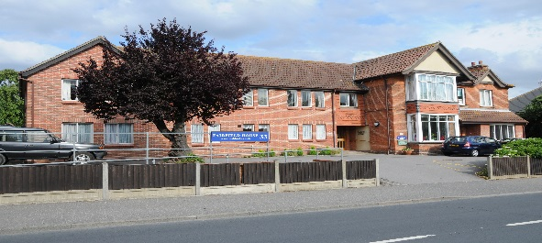
Fairfield House

